COM – 211

Library Exercise

Part I

- Finding a Book
- Accessing an Electronic Book
- Finding Information on the World Wide Web

Part II

- Finding Articles in Magazines and Journals
- Finding Articles in Major Newspapers

To complete this exercise:

Visit the Library's website:
http://library.sinclair.edu

Visit the Library in the
Lower Level of Building 7.

You can also enter the Library from the Basement Level of Buildings 1-7.

- Finding a Book http://library.sinclair.edu/
Tip: At the Library’s website, click “Search the Sinclair Library Catalog” in the middle of the screen.

- Select and circle one of the topics below, then
- Find a book on the topic:
Tip: Click the radio button marked “Subject,” then enter your search term.

Topics: body language , broadcasting , communication , interviewing , listening ,
motion pictures , public speaking , e-mail
Subject Search
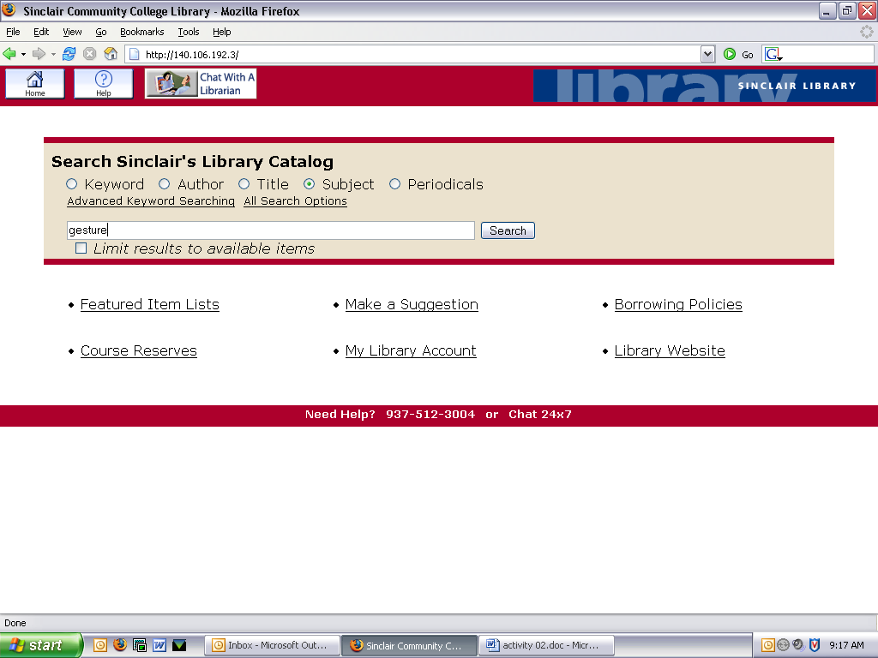
Enter your search term.
Click the Search Button.

- Give the following information for the book that you have found:

Author:

Title:

Place of publication: ________________ Name of publisher: _________________________

Date: _____________ Call number: _________________________ or □ Electronic book

- Accessing an Electronic Book

The Sinclair Library has numerous electronic books. These are online books that you can display on your screen. You can find e-books by searching the Library's Catalog or you can click Electronic Books on the Library’s website to find more.

- Search for the title Statistical Abstract of the United States. Use the electronic version of the book to answer the question at the top of the next page:
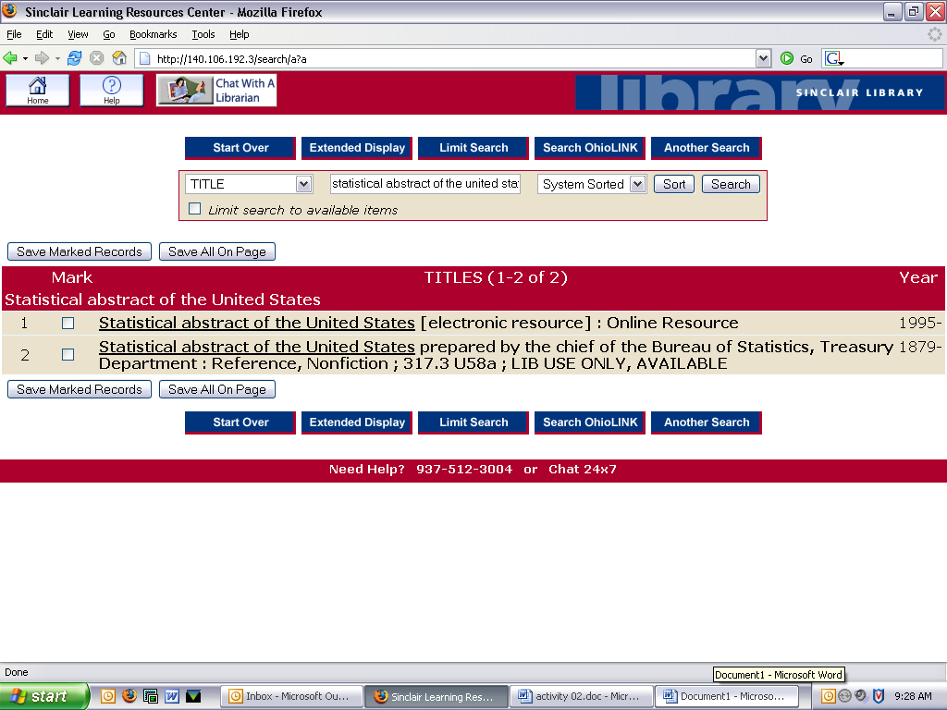

B. Accessing an Electronic Book (continued)

- What are the projected hours of television viewing time per person per year spent on network stations for 2007?

Tip: Use the Index near the bottom of the blue list to look up relevant terms. The index will give you a table number. Then go back to the blue list and click on the link for the number.

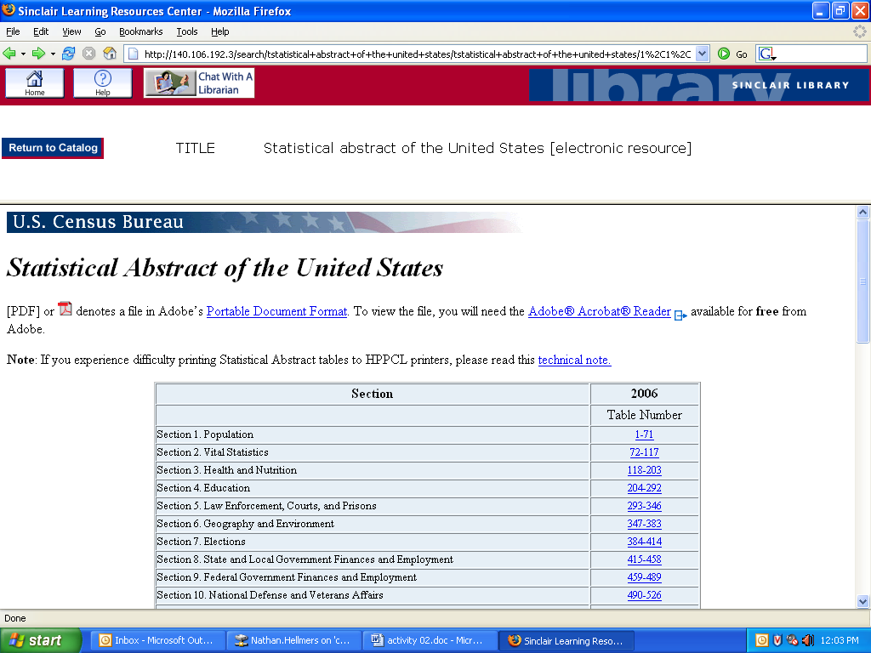

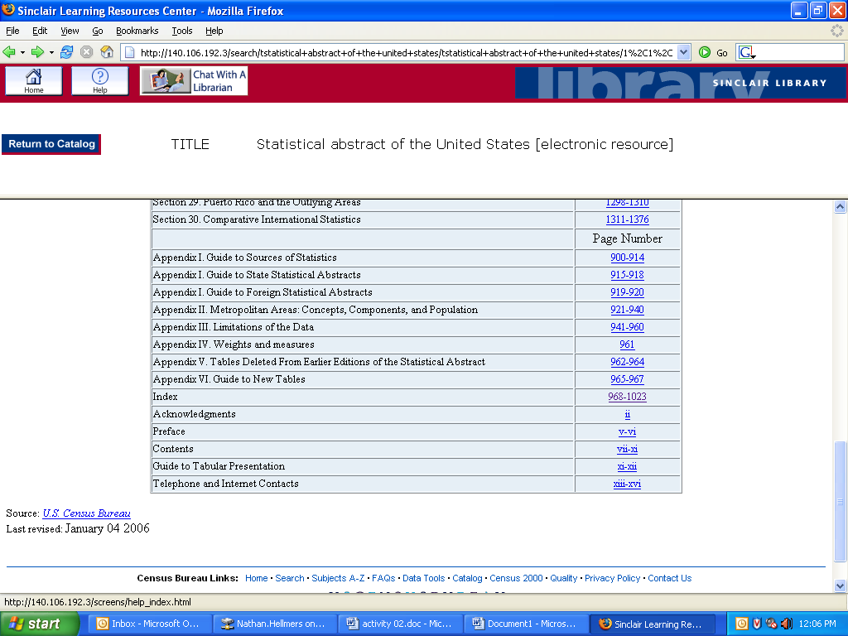

Finding Information on the World Wide Web

The World Wide Web offers a lot of good information, but not everything is reliable. You must critically analyze and evaluate the information found. Here are two websites that give techniques and guidelines on how to determine the quality of a website:

http://library.usm.maine.edu/research/researchguides/webevaluating.html
http://www.2learn.ca/evaluating/evaluating.html

- Use a World Wide Web search engine (For example: google.com, yahoo.com, or alltheweb.com) to locate a website on "communication arts”
Tip: Use quotation marks for a phrase search.

- What's the address for the website you found?

C. Finding Information on the World Wide Web (continued)

- Cite the web page found in Question 2 in MLA style.
Tip: Use the MLA handout on the Sinclair website. Click “Guides and Handouts.”

- Using the evaluation techniques you have learned from the two websites listed on the previous page, identify two major reasons why you selected this particular website.

a)

b)

- Finding Articles in Magazines and Journals

  - Use the two websites below as references; put these five periodical titles in the appropriate category – 1. magazines and 2. journals.

http://lib.utsa.edu/Research/Subject/scholarlyguide.html
http://www.lrc.macewan.ca/research/guides/periodical_types.html

Magazines/Journal titles: U.S. News & World Report , Vital Speeches of the Day ,
World Press Review , Money , Journal of Communication

Magazines | Journals

- Use the list of Magazine and Journal Databases on the Sinclair Library website to locate a periodical article.

Tip: Click "Articles", then click "General"
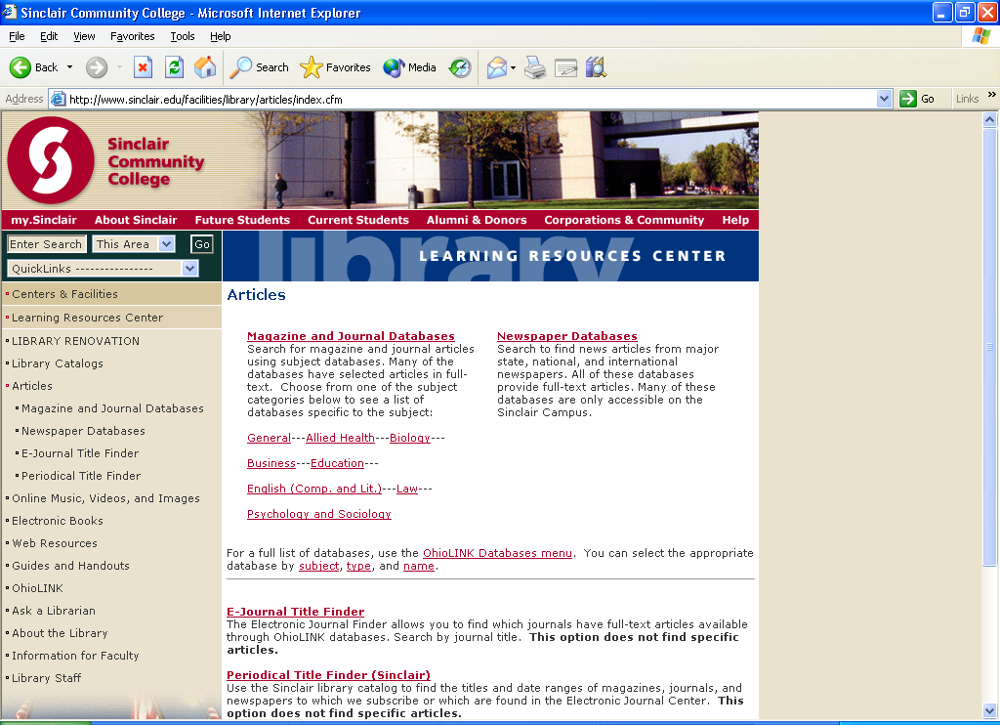

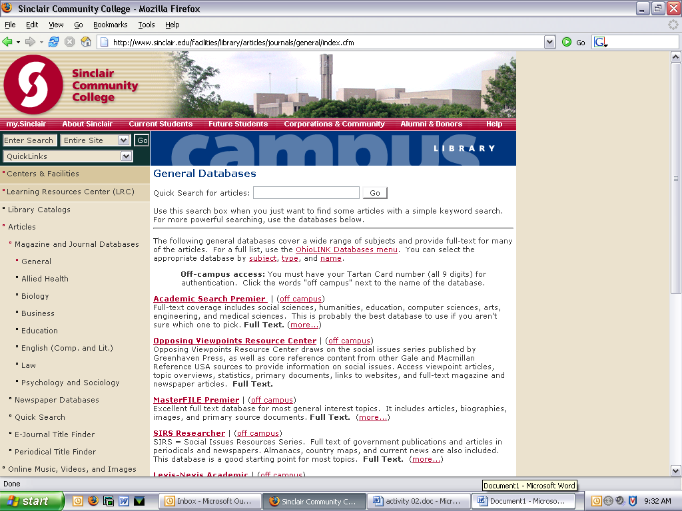
Click "Off campus" if you are accessing from off campus.

- Finding Articles in Magazines and Journals (continued)

  - Circle a topic you are interested in and identify two databases that you think may contain information on your topic.
Tip: Read the description of each database. Click (more …) for detailed information.

Topics: allied health , business , world news , consumers , media , technology ,
social science , education

a).

b).

- Use the database Academic Search Premier and find an article on a social issue published in CQ Researcher. Printed copies of this publication are located in the Reference Collection of the Sinclair Library.

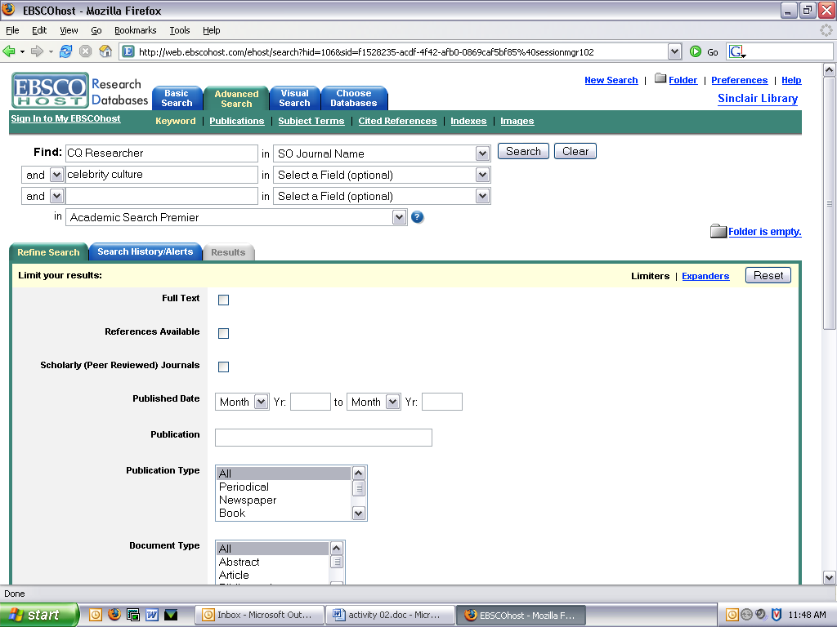
Tip: Click on Academic Search Premier. In the search box, type "CQ Researcher." Click the down arrow after "in" and select "SO Journal_Name."

You can type your search term(s) in the second search box.

Complete the following:

Title of article:

Title of periodical: CQ Researcher

Date: ____________________ Volume: ________ Issue: _______ Pages: ______________

- Finding Articles in Magazines and Journals (continued)

- Using the database Opposing Viewpoints, find a "Viewpoint" essay you are interested in and complete the following:

Click a subject on the list OR enter your topic word(s) here, select a search, and then click the Search Button..

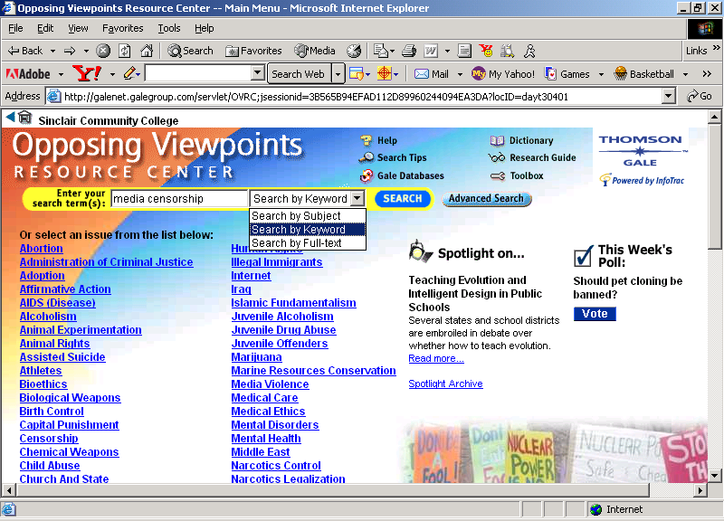

The tab indicates the category of the articles listed.

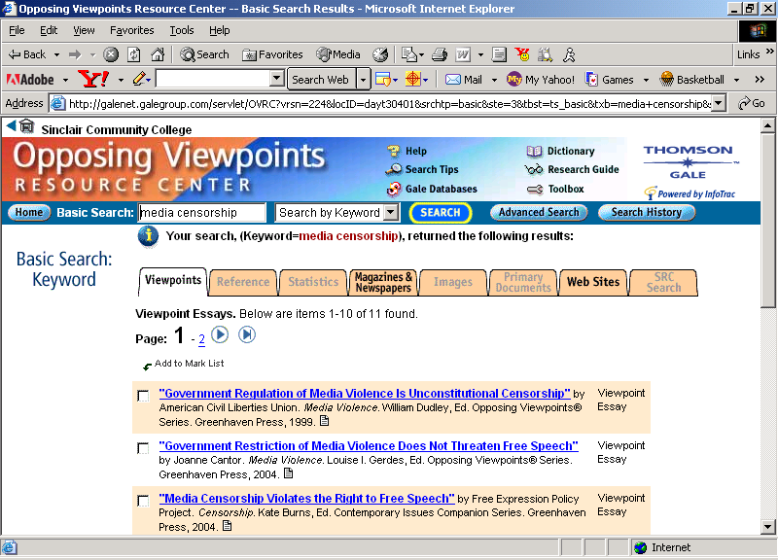

List of “Viewpoints” essays.

Complete the following:

Author:

Title:

Title of original publication: (Tip: Scroll down and look in "Source Citation.")

Name of Database:

Date of access:

- Finding Articles in Major Newspapers

There are many databases in which you can locate citations or full text articles published in major newspapers nationally or internationally. Use the Library's Newspaper databases.

- Search the Dayton Daily News Online Archives and find an article about:

homelessness or domestic violence

Tip: Click Articles and then click Newspaper Databases. Scroll down to select Dayton Daily News Online Archives.

Title of article:

- Print the first page of the article and attach it to this exercise.
Tip: Go to "File," click "Print," and select the number of pages.

